2016 SPECIAL EVENTS
Shades State Park & Turkey Run State Park

Friday, January 1, 2016
Shades State Park

First Day Hike
Start the year off with an exhilarating 2-hour moderate winter walk in beautiful Shades State Park. Meet near the DNR vehicle in the Hickory Shelter parking lot at 1:30pm to look for tracks, eagles, winter birds and more! Bring binoculars. Snacks & water provided.

Friday, January 1, 2016
Turkey Run State Park

First Day Hike
Meet at the nature center at 11 a.m. for a rugged 1-hour New Year’s Day walk to look for ice formations, eagles and whatever else the winter’s day brings.

Fri, Sat & Sun, January 29-31, 2016
Turkey Run State Park

Eagles In Flight Weekend

Weekend activities include live raptor programs, plus both eagle roost and nest carpool tours. Program fee $15 for ages 14 & up, $10 for ages 4-13, & under 4 free. Reserve a lodging package for the Turkey Run Inn at 1-877-LODGES1.

Friday, April 15, 2016
Turkey Run State Park

Richard Lieber Memorial

Dedication Ceremony

See the beautifully restored Richard Lieber Memorial as we celebrate and honor this great man. RSVP to tlthompson@dnr.in.gov.
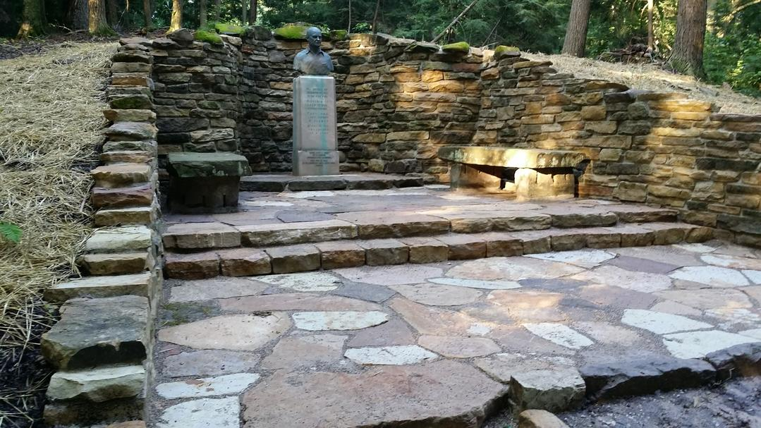

Friday - Saturday, June 24-25, 2016
Shades State Park

5th Annual Chautauqua
Music, magic, art, food and fun under the big tents at the Hickory Shelter

Sunday, June 26, 2016
Shades State Park

State Parks’ 100th Birthday Bash
At the Hickory Shelter

Saturday, July 16, 2016

Turkey Run State Park

Pioneer Heritage Festival
Try out life skills from our Pioneer era: soap and candle making, games & toys, cross cut sawing, home-made ice cream and more!

Sunday, July 17, 2016
Turkey Run State Park

Turkey Run’s 100th Birthday Celebration!

Saturday, September 24, 2016
Turkey Run State Park

National Public Lands Day
Work Day; give something back to the parks you love and help clean up the trails or eradicate non-native plants. Bring work gloves, drinking water & a sack lunch. Join thousands across the nation in taking care of our public lands!

Saturday, October 28-29, 2016
Turkey Run State Park

Halloween Camping Weekend
People & Pet costume contests, Campsite Decorating Contest, creepy programs, trick-or-treating and more! Make camping reservations at Camp.IN.gov or 1-866-622-6746.
www.INStateParks100.com

